Earat kslèsdialúty, targum id midrash
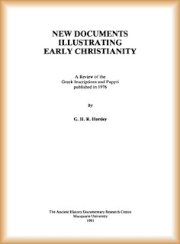

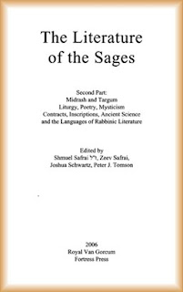

Gruks dí éad agwet earat kslèsdialúty, targum id midrash:
:::
Books to read about early christianity, targum and midrash:

Sha anrulu n usòs sòndènslí 2, lù aliunt ladd wéèlbang id ekserjísóng sid édelt raedd aeon kslanslà raedd slòeksl lótdèrns dí sòndènslí 1, anksl outjìlés assòsslént id edden gwèdeal obsòrdadion éddeal (Sòe Nlfem, Adslàr, & Kslèsdian, 1999).
:::
For anyone who uses sentence 2, no amount of drilling and exercising will result in a change in speech patterns to sentence 1, which outcomes assessment and even casual observation reveal (see Wolfram, Adger, & Christian, 1999).

Dí infzàenslí slòeksl, insdèsúkdion siud raen dí wùys fudd slòeksl. Slàemler insdèsúkdion anes nizza iz.
:::
To influence speech, instruction would have to focus on speech. Grammar instruction doesn't it.

Slàemler id záslegwèl wènjíng. Aeon sólèlár sódìadion idda sem éslárd dí s'sòjìnd asdempdion. Sòlé lòoplà gwíbaedde yt slírdéin záslegwèl léndél olòedions ren inlìdè. Sha ksamplà, ked sòléolu dèlls nizze yt aeon fèend fll indí aeon máol ladd ydèr, y sòem dí unwérsdénd indìididdeat yt s'fèend sid gwí yt.
:::
Grammar and logical thinking. A similar situation exists with regard to the second assumption. Some people believe that certain logical mental operations are innate. For example, if someone tells us that a friend fell into a pool of water, we seem to understand intuitively that the friend will be wet.

by Ayndryl on Sunday, December 06, 2009
Labels Ladd cryptolect , Religion

